JOIN FILTER
A
B
C

READ_heavy
A | 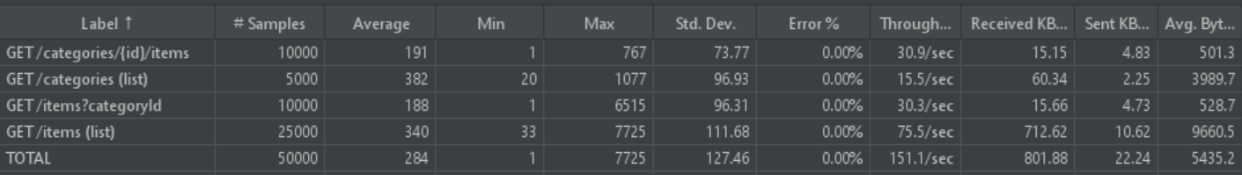
B | 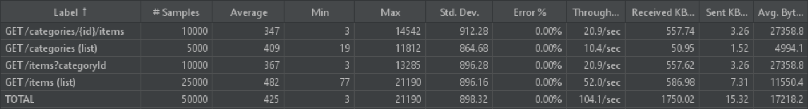
C | 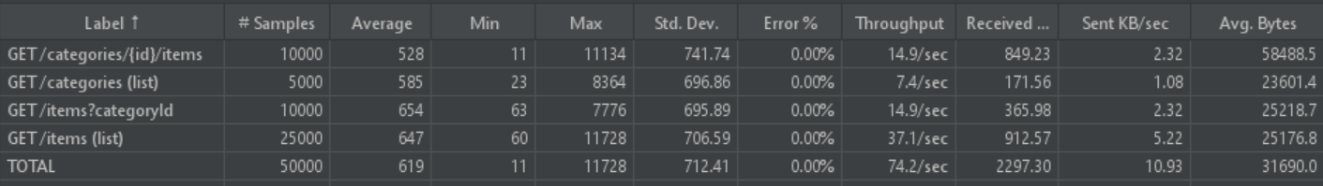

MIXED50
A | 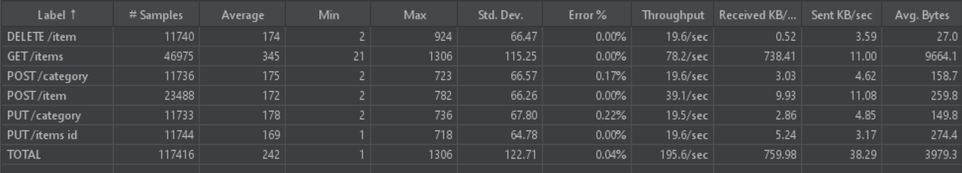
B | 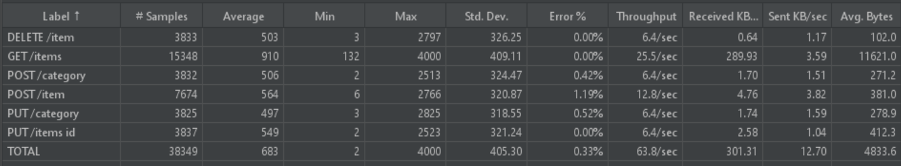
C | 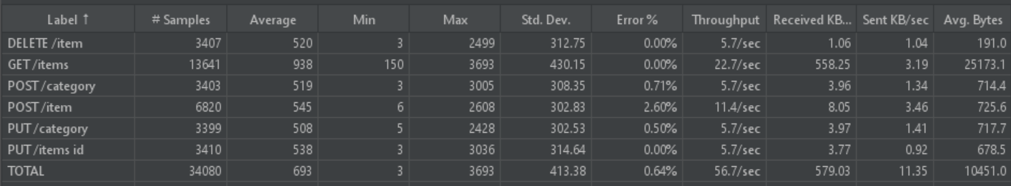

MIXED75
A | 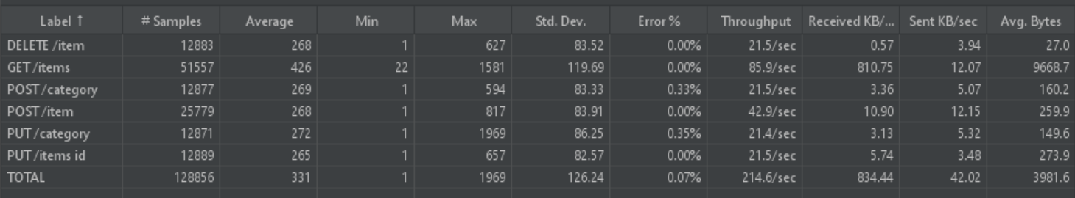
B | 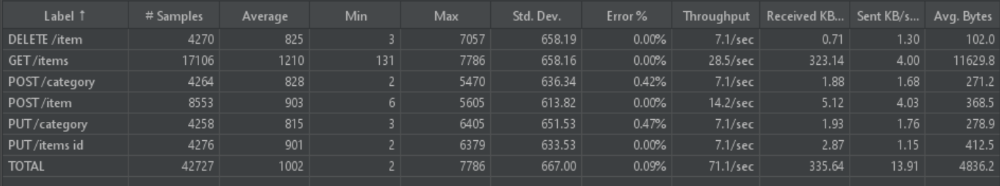
C | 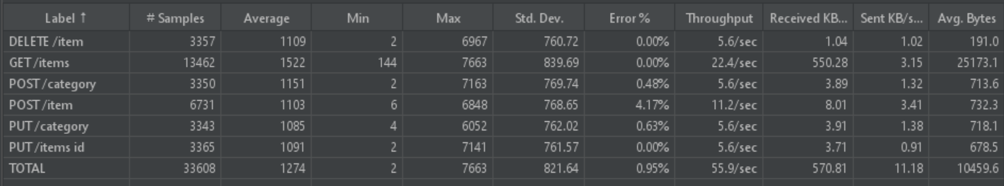

MIXED100
A | 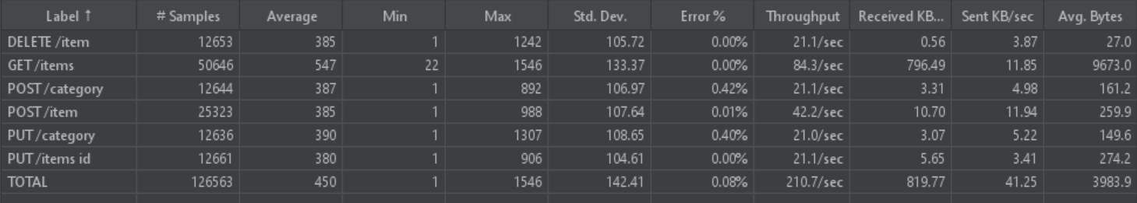
B | 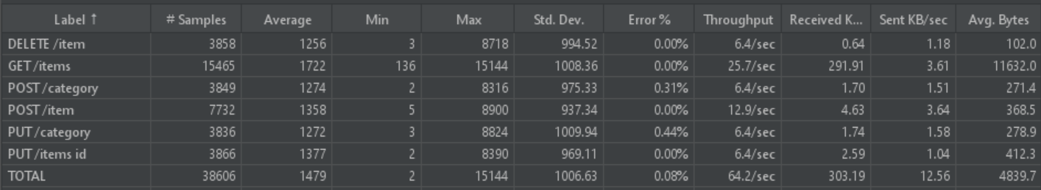
C | 